Amsterdam

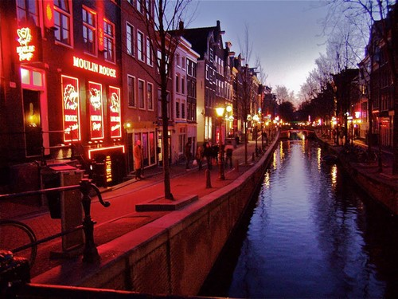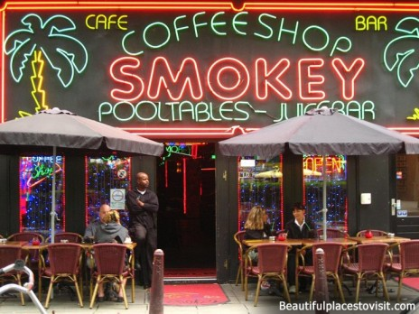

Figure 1 : Coffee Shop

Figure 2 : Red Light District

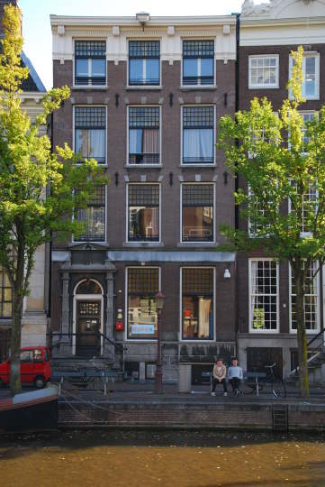

Figure 3 : Stayokay Amsterdam Stadsdoelen

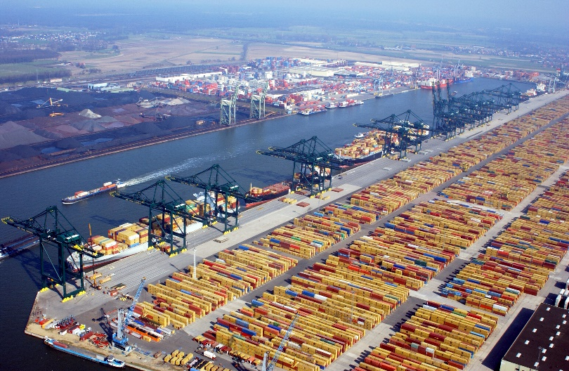

Figure 4 : Rotterdam Port

Berlin

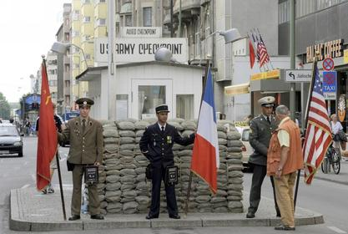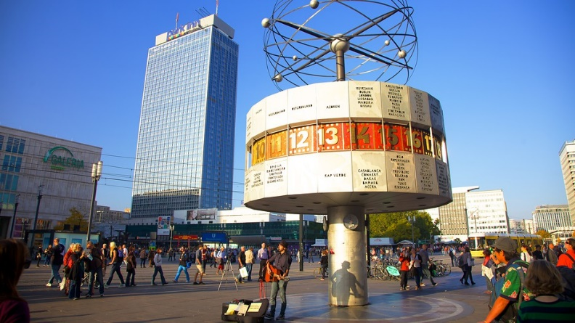

Figure 5 : CheckPoint Charly

Figure 6 : AlexanderPlatz

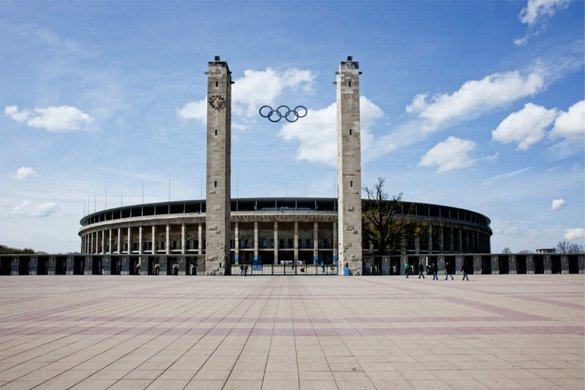

Figure 7 : OlympiaStadion

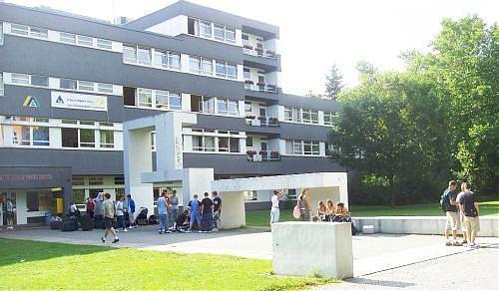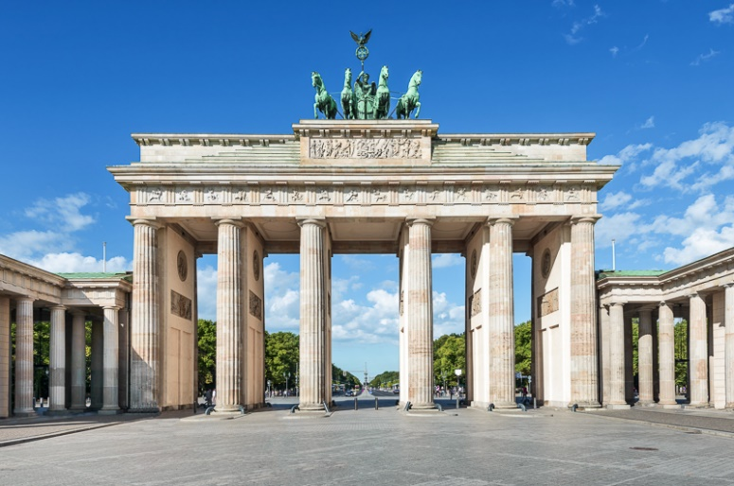

Figure 8 : Youth Hostel International

Figure 9 : Brandenburg Tor

Vienna

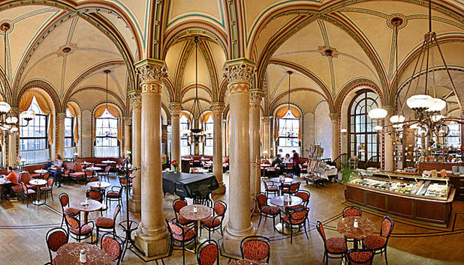

Figure 10 : Café Central

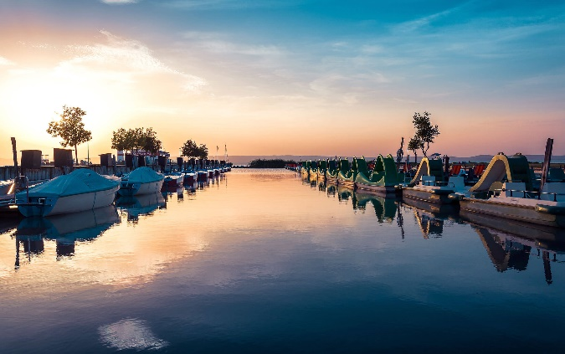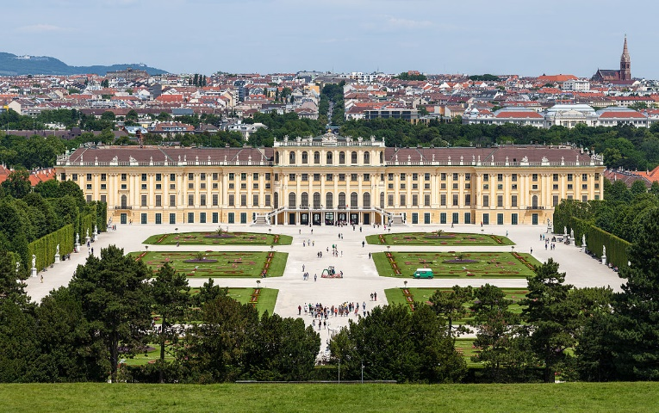 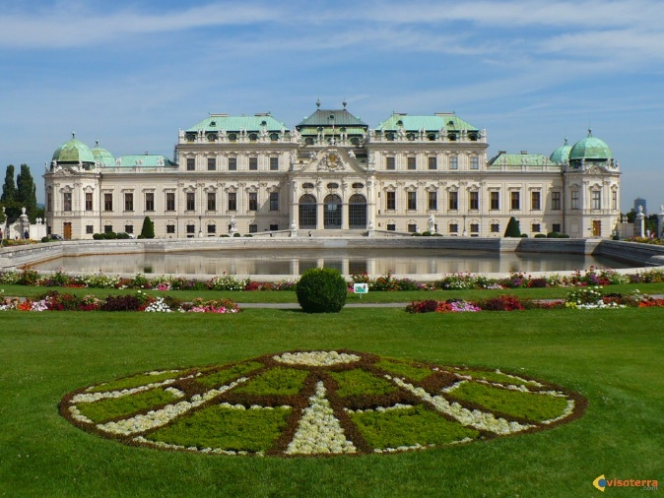

Figure 11 : Lake of Neusiedl

Figure 12 : Castle of Schonbrunn

Figure 13 : Belevedere

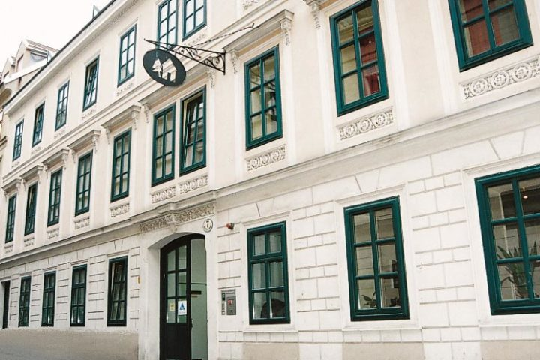

Figure 14 : Myrthengasse

Turin

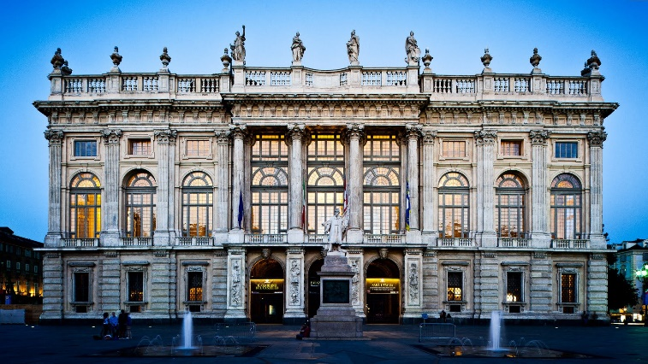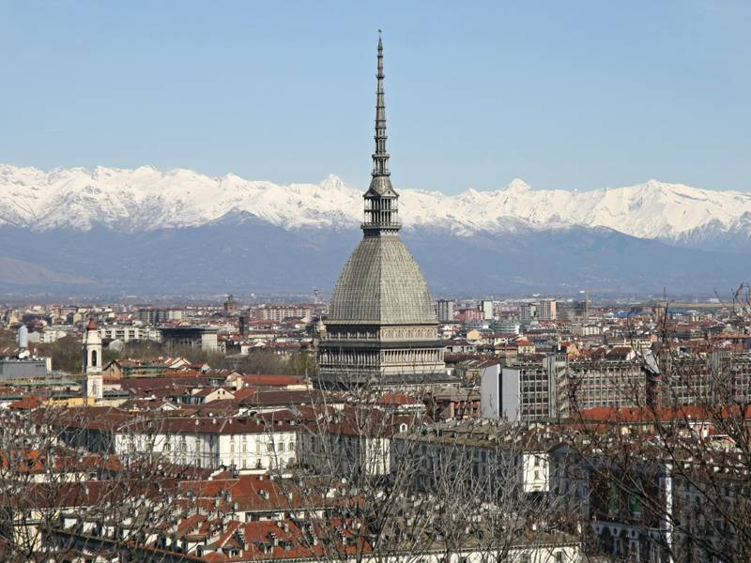

Figure 15 : Mole antonelliana

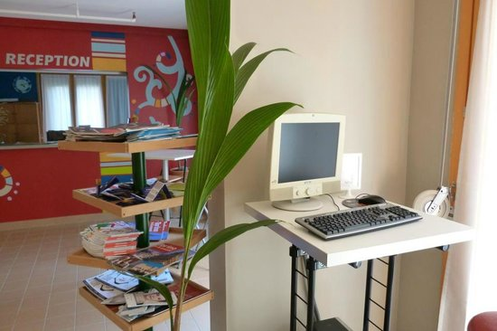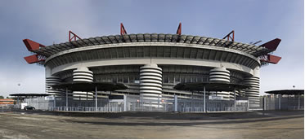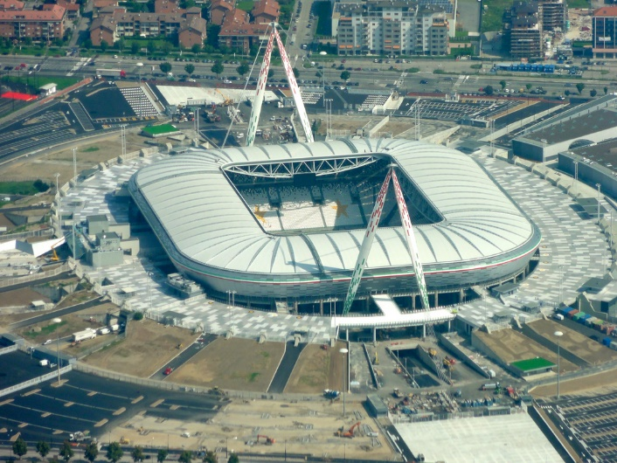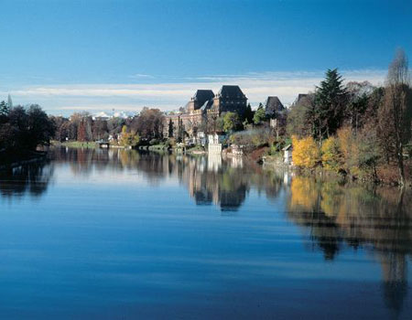

Figure 16 : Torino hostel

Figure 17 : San Siro

Figure 18 : Juventus Stadium

Figure 19 : parco del valentino

Figure 20 : Palazzo Madama

Nice

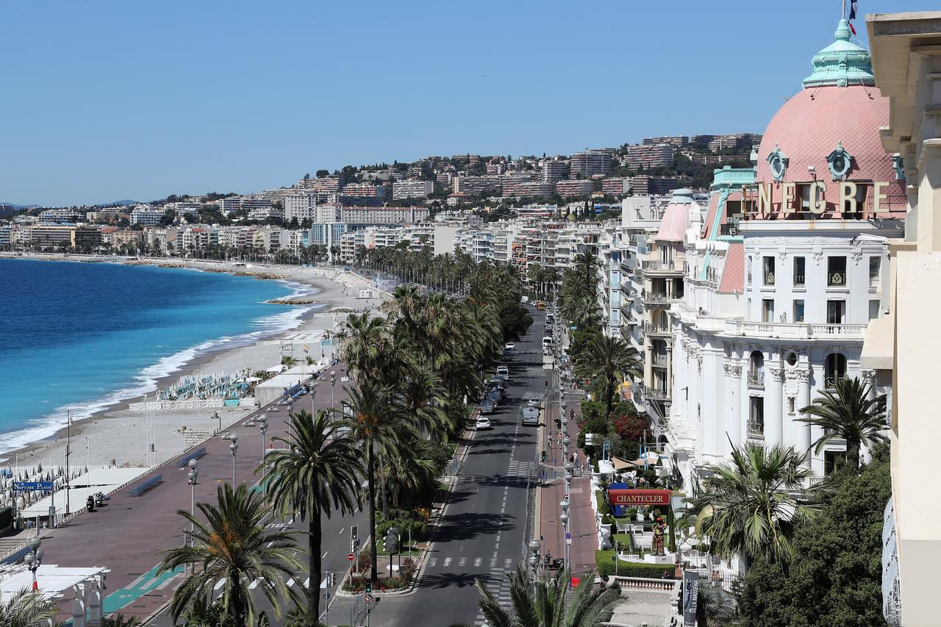

Figure 21 : Promenade des Anglais

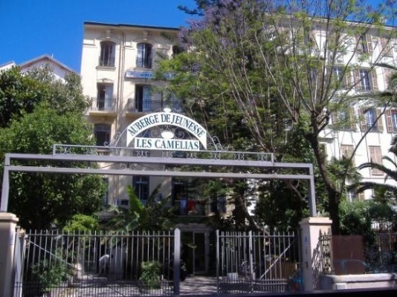

Figure 22 : Hi Nice Camelia

Madrid

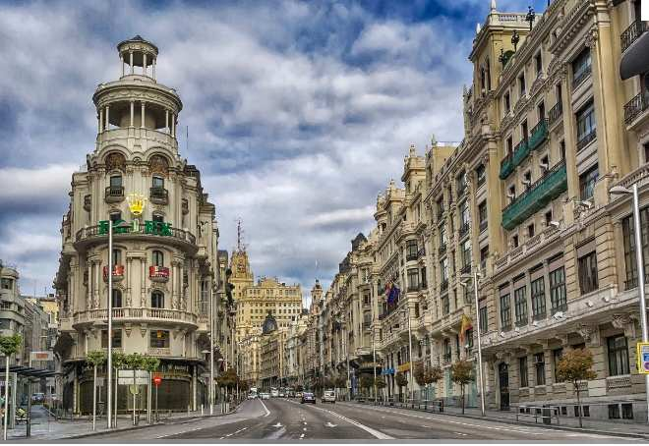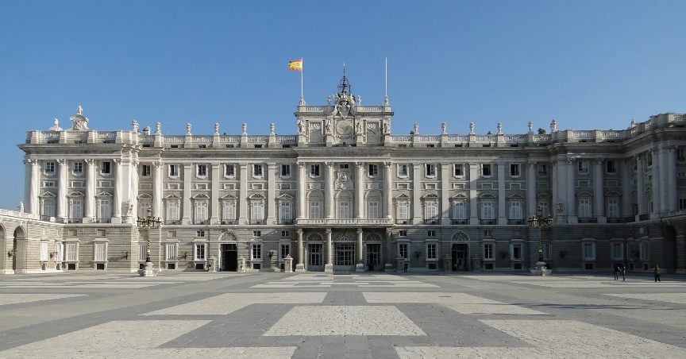

Figure 23 : Royal Palace

Figure 24 : Gran Via

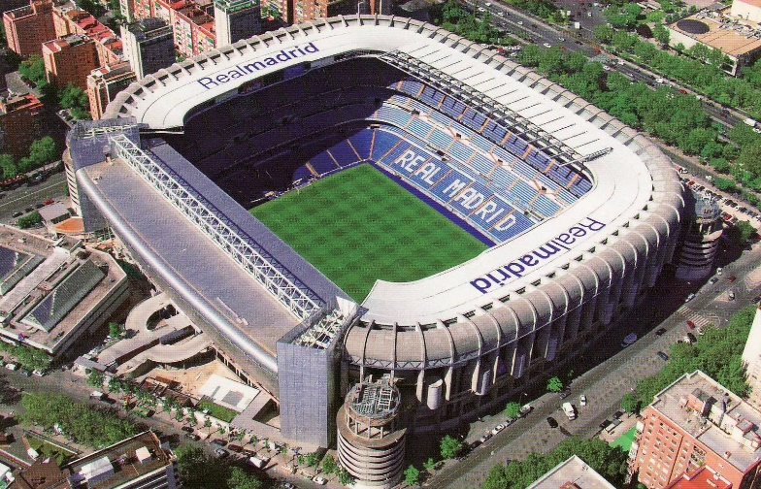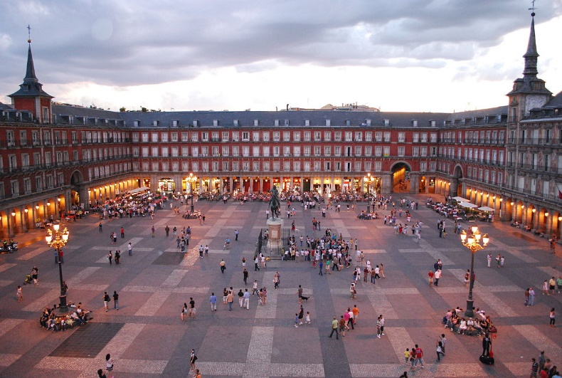

Figure 25 : Santiago Bernabeu

Figure 26 : Plaza Mayor

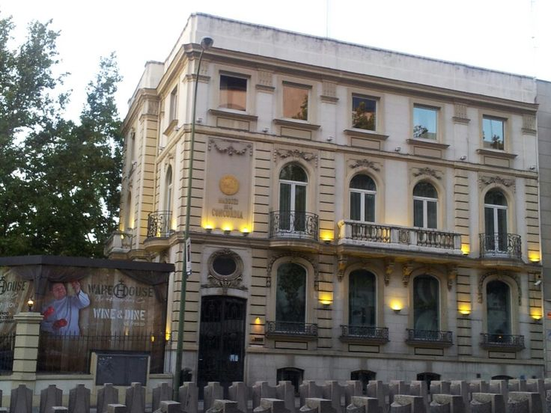

Figure 27 : Concordia